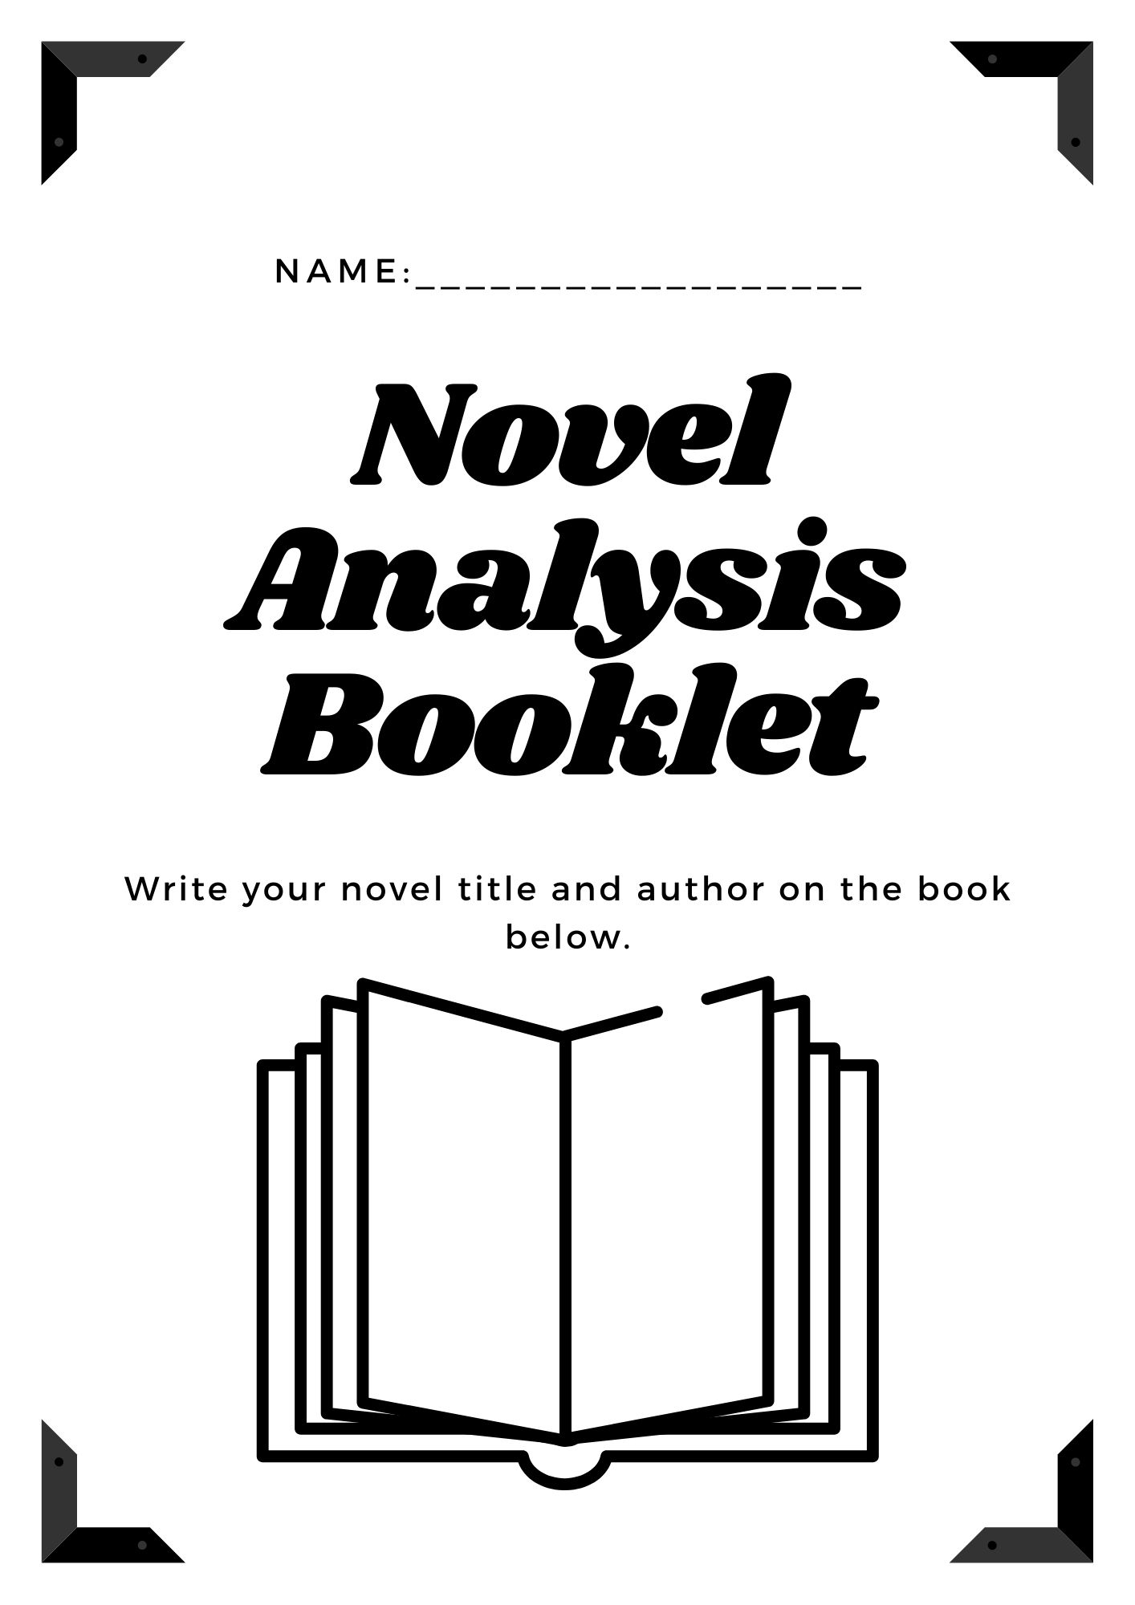

**Contents**

**Page 2 & 3…….Plot**

**Page 4 & 5…….Context**

**Page 6…….Narrative Elements**

**Page 7…….Characters**

**Page 8 & 9…….Theme**

**Page 10…….Setting**

**Page 11…….Language**



**PLOT ACTIVITY**

|  |  |
| --- | --- |
| **SECTION OF THE BOOK** | ***WHAT’S HAPPENING IN THE NOVEL? Include one key quote from each section.*** |
|  |  |
|  |  |
|  |  |
|  |  |
|  |  |
|  |  |
|  |  |
|  |  |

|  |  |
| --- | --- |
| **SECTION OF THE BOOK** | ***WHAT’S HAPPENING IN THE NOVEL? Include one key quote.*** |
|  |  |
|  |  |
|  |  |
|  |  |
|  |  |
|  |  |
|  |  |
|  |  |

**Social and Cultural Context**

Social attitudes in different times and places have an effect on the author and the reader. Authors cannot avoid being influenced by their social experiences. Some writers don’t agree with their society’s values.

Culture includes the skills, arts and customs that are passed down from generation to generation. Most countries in the world have special traditions and customs.

**Author Context**

The background and experiences of authors and artists have a considerable effect on the texts that they create. Authors (and artists) are influenced by their own life experiences and the lives of those around them. Examples: gender, occupation, age, interests, education, values, ethnicity, life experiences, family and culture.

**Context**

Texts are not created in isolation. There are many influences and factors that affect the creation of a text and the way the audience responds to it. Context is the circumstances, background and setting of a particular situation and time that a text was created. It will help you understand a text if you take into consideration it’s personal, social, cultural, and historical context.

**Personal Context**

Your personal values, beliefs, experiences, family, culture, ethnicity, interests and time in history will influence the way you respond to a text.

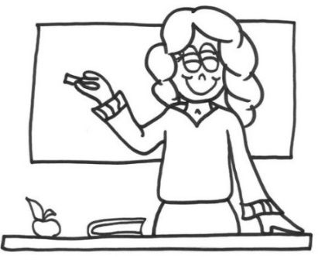

|  |  |  |  |
| --- | --- | --- | --- |
| ***This can include:*** | | | |
| gender  religion  occupation  beliefs | culture  interests  education  ethnicity | friendships  life experiences  values  ideology | age  attitudes  family |

**In your own words, summarise personal, author and social/cultural context in the space below.**

* Personal
* Author
* Social/Cultural

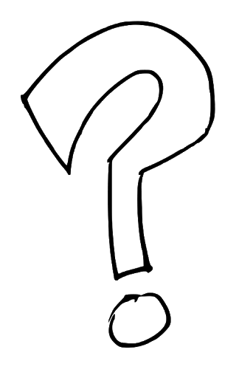

**Fill in the context table below based on the novel you are reading.**

**Author**

*Where is the author from? What is his background? Does this relate to the novel?*

**Social**

*What is/was happening in the world when this text was written?*

**Personal**

*Your own experiences and beliefs that affect your understanding of the novel. Can you relate to the novel?*

**Novel**

**NARRATIVE ELEMENTS**

**PLOT –** What happens in the story; the sequence of events in any narrative that unfolds as we read.

**SETTING –** Where the story takes place – discuss the time and place and the atmosphere created.

**POINT OF VIEW –** Refers to who is telling a story, or who is narrating it. The narration of a story or novel can be told in three main ways: first person, second person, and third person.

**CHARACTERS –** The people involved in the story; there are usually major characters and minor characters; protagonists and antagonists.

***Protagonist* –** Usually the main character in a narrative, but also the most important person in any particular situation.

***Antagonist* –** Is the chief opponent or rival of the protagonist in a narrative and is used to block the efforts of the chief character to attain his or her goal.

**CONFLICTS –** Is the struggle between two opposing forces. There are four main types: person vs person, person vs self, person vs nature/environment, person vs society.

**THEMES –** The central idea or comment on some important issue that lies behind the events in a narrative.

**_________________________________________________________________________________________________________________________________________________________________________________________________________________________________________________________________________________________________________________________________________________________________________________________________________________________________________________________________________________________________________________________**

**Using the novel you are reading, fill in the table below.**

|  |  |
| --- | --- |
| **Narrative Element** | **Description and evidence/quotes from the novel.** |
| Plot Summary   * *What happens in the story?* * *What happens in the beginning, middle and end?* * *Is the plot chronological, are flashbacks used?* * *Is there a clear resolution? If yes, describe it.* |  |
| Point of View   * *First, second or third.* * *Describe and give examples.* * *What effect is created?* |  |
| Conflict   * What types of conflict are explored in the novel? * Describe these. * How do the characters deal with these conflicts? |  |

**CHARACTERISATION**

Characters are the driving force behind stories, both major characters and minor ones. Authors use them to broadcast their most important messages.

Choose **one main character** from your novel and provide details on **how the author has developed them**. You may write your ideas as dot points. You must explain each idea in relation to the story. You **MUST include quotes** to support your ideas. **Demonstrate your interpretation** of this character, in detail.

|  |  |
| --- | --- |
| SPEECH - **What does the character say and how do they say it? Provide examples. What does this tell you about the character?** | ACTIONS - **What does the character do? Provide examples. What does this tell you about the character?**  **Main Character** |
| APPEARANCE - **What does  the character look like? How  do they dress?  Provide examples.  What does this tell you about  the character?** | OTHERS - **What do other   characters say about this   character?  Provide examples. What does this   tell you about the character?** |

**Themes**



* **The author’s message**
* **The universal lesson**
* **The BIG idea**

Themes are big ideas that authors comment on throughout a work using tools such as context, setting, and characters.

Some common themes are to do with subjects such as good vs. evil, human nature, religion, social structure, authority, coming-of-age, human rights, feminism, racism, war, education, sex, friendship, love, compassion, and death. Most books deal with multiple themes, some more obvious than others.

**How do you find THEME in a story?**

**Ask yourself some questions:**

* Has the **MAIN CHARACTER** of the story changed?
  + If so, what have they learned?
* What was the main **CONFLICT** or **PROBLEM** in the book?
  + How was it resolved?
* Does the **TITLE** have a significant **MEANING**?

**In the space below, brainstorm some of the possible themes for your novel. Select one of these themes and fill in the Thematic Mind Map on the next page.**

**Thematic Mind Map**

**THEME:**

**SETTING**



Setting is an important part of any story or poem because it explains where and when the events take place. The setting helps create the mood and set the tone for the literary piece. You can analyze the setting by **examining the surrounding environment, background, historical place in time and geographic location**. Use specific examples from the story to support your analysis.

|  |  |
| --- | --- |
|  | **SETTING/S** |
| **TIME** (period in history, year, time of day) |  |
| **PLACE** (use your senses to describe it – sight, sound, smell) |  |
| **ATMOSPHERE** (the mood/feelings created by the author through the words used)  **What effect does this have on the reader?** |  |
| **Why do you think the author has chosen to use this setting?**  **Does it help to establish/develop other elements of the narrative such as conflict or characterisation?**  **Does this setting symbolise something for you or for the main character?** |  |

**LANGUAGE AND STYLE**

**Definitions**:

Figurative language: _______________________________________________________________________________________________________________________________________________________

Descriptive language:

______________________________________________________________________________________________________________________________________

|  |  |
| --- | --- |
| Simile |  |
| Metaphor |  |
| Personification |  |
| Hyperbole |  |
| Imagery |  |

|  |  |  |
| --- | --- | --- |
| **Words or phrases from the novel (include page numbers)** | **Figurative Language Device** | **Effect created** |
|  |  |  |
|  |  |  |
|  |  |  |
|  |  |  |
|  |  |  |
|  |  |  |
|  |  |  |